Zyverse Clinic Management System - Your Comprehensive & Intuitive Clinic Management Solution
Introduction:
Revolutionize your medical practice with Zyverse Clinic Management System – the all-in-one management system designed for small clinics, growing multi-location practices, and ambitious new startups. Say goodbye to administrative headaches and hello to seamless operations, enhanced patient care, and complete financial clarity. Zyverse Clinic Management System combines powerful features with unparalleled ease of use, robust integrations, and exceptional support to empower your clinic's success.

  - Why Choose Zyverse Clinic Management System?
- Effortless Ease of Use: Navigate your daily tasks with a clean, intuitive interface that requires minimal training. Get your team up and running quickly, allowing them to focus on what matters most: patient care.
- Seamless Integrations: (Specify if you have any particular integrations, e.g., "Integrates with leading accounting software" or "Connects with online booking platforms.") Zyverse Clinic Management System is built to fit into your existing ecosystem, ensuring smooth data flow and eliminating silos.
- Exceptional Support: Our dedicated support team is here for you every step of the way. From onboarding to daily queries, expect prompt, knowledgeable, and friendly assistance to ensure you maximize Zyverse Clinic Management System's potential.
- Scalable for Every Practice: Whether you're a solo practitioner, managing multiple locations, or just starting, Zyverse Clinic Management System grows with you, offering flexible solutions to meet your evolving needs.

  - Key Features & Benefits:
1. Intuitive Appointment Scheduling & Management:
- Dynamic Calendar View: Effortlessly view and manage daily appointments for all your doctors/practitioners and staff.
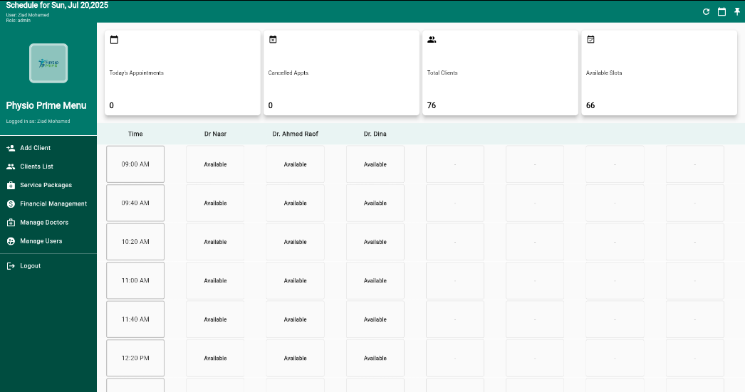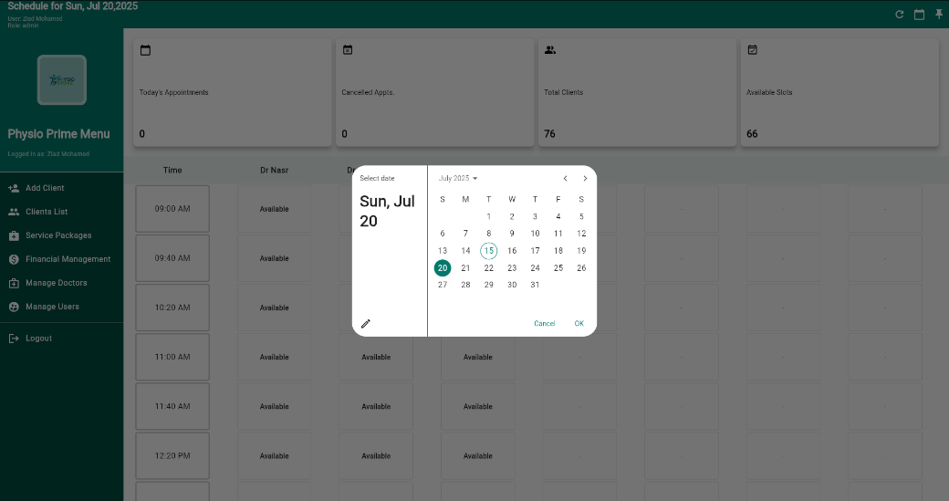
- Real-time Availability: Quickly identify and book available slots, minimizing scheduling conflicts and optimizing your team's time.
- Reduce No-Shows: Streamlined booking processes help improve patient adherence to appointments.
- Benefit: Boosts clinic efficiency, maximizes resource utilization, and enhances the patient booking experience.
2. Comprehensive Client/Patient Relationship Management:
- Easy Patient Onboarding: Quickly add new patients with essential details including name, age, phone number, and detailed notes for personalized care.
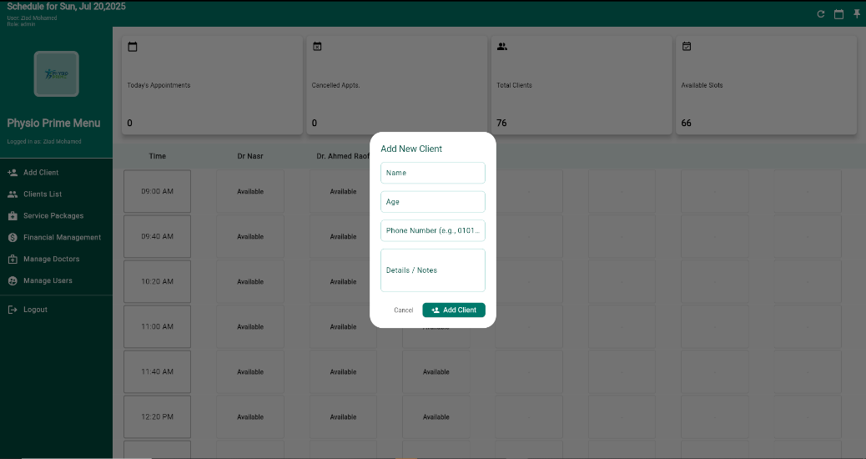
- Centralized Records: All client/patient information is stored securely and accessible in one place for quick retrieval and better patient engagement.
- Benefit: Improves patient data accuracy, facilitates personalized treatment plans, and strengthens client/patient relationships.

3. Streamlined Doctor/Practitioner & Staff Management:
- Flexible Availability Settings: Easily define and update each doctor's/practitioner's and staff member's working days, ensuring accurate scheduling.
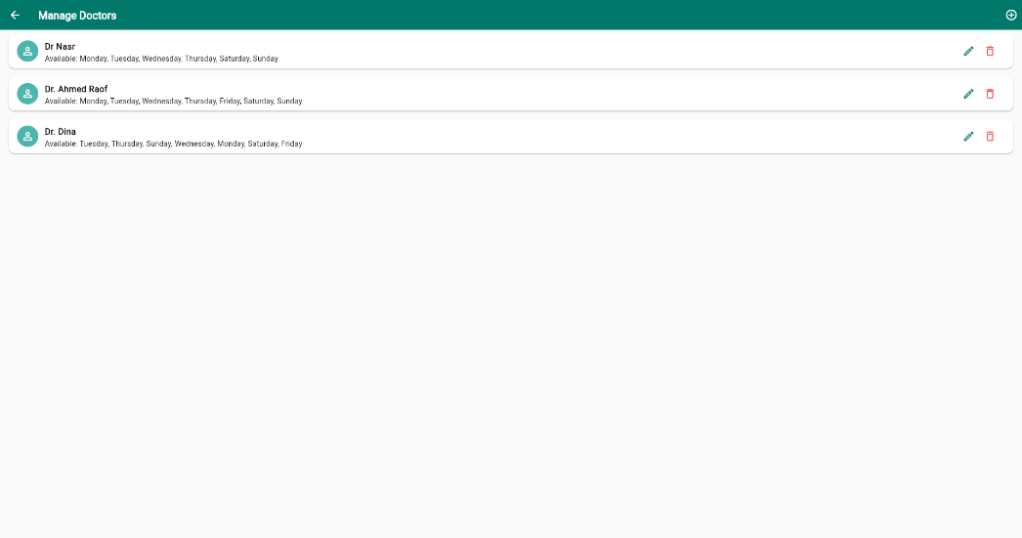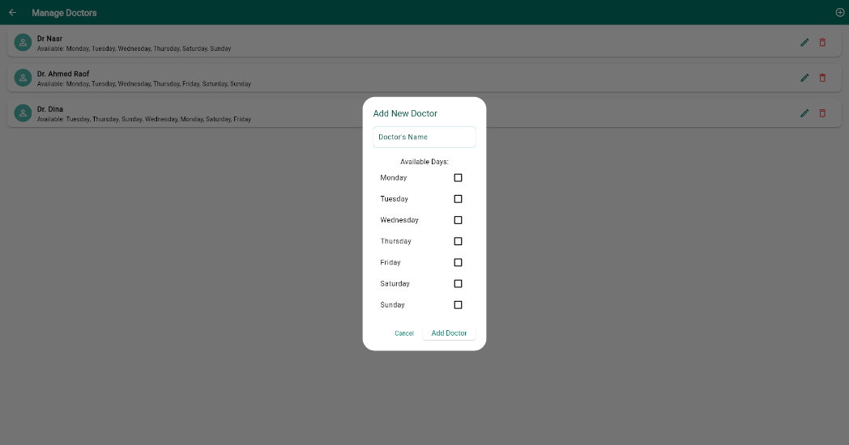
- Dedicated Profiles: Maintain comprehensive profiles for all your medical staff.
- Benefit: Optimizes staff scheduling, reduces administrative overhead, and provides a clear overview of your team's capacity.

4. Advanced User & Role Management:
- Secure Access Control: Assign distinct roles (Admin, Doctor/Practitioner, Desk, etc.) to users, controlling access to sensitive information and specific functionalities.
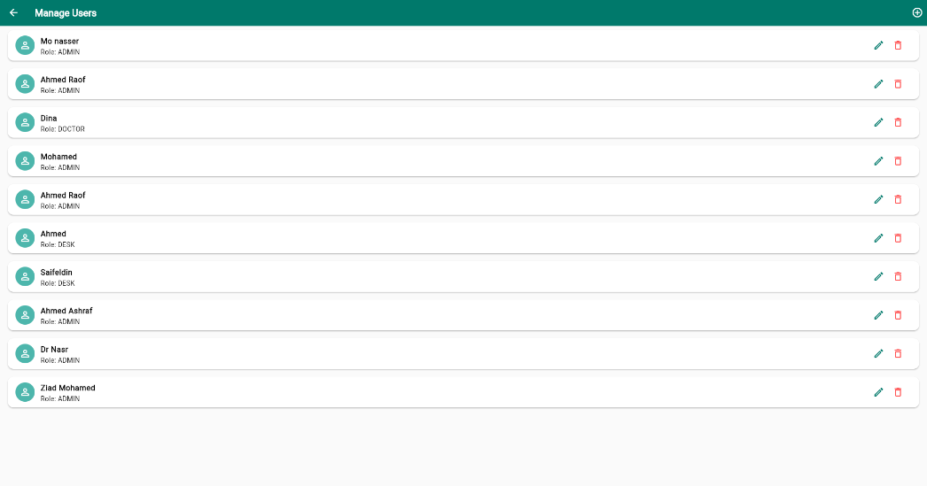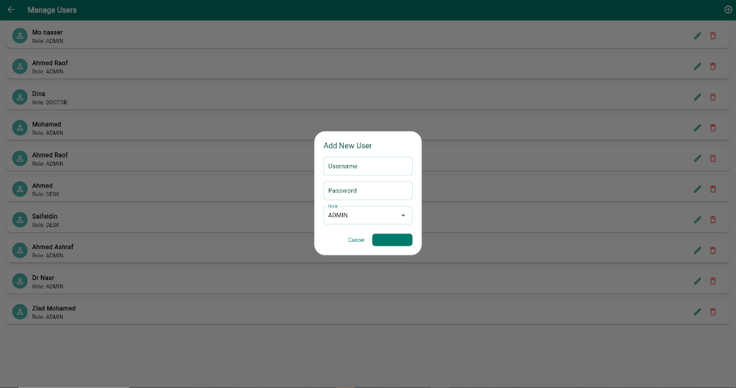
- Customizable Permissions: Tailor user permissions to align with your clinic's operational structure.
- Benefit: Enhances data security, ensures operational integrity, and clearly defines responsibilities across your team.

5. Smart Financial Oversight:
- Daily Financial Summary: Get a clear overview of your clinic's daily payments, purchases, and bills.
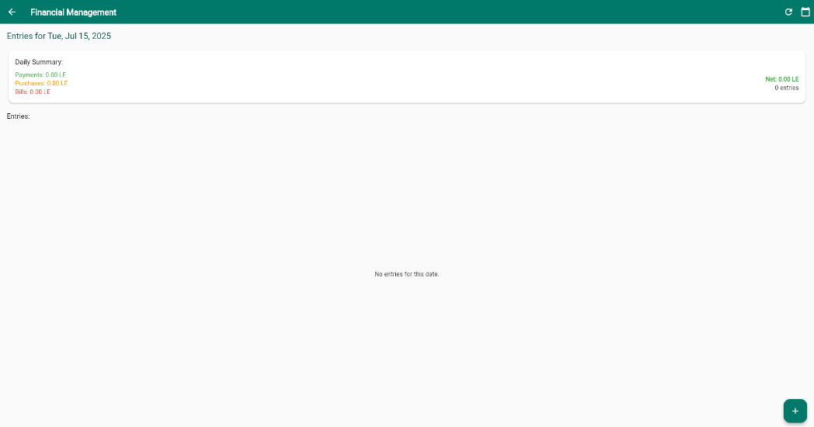
- Detailed Entry Tracking: Easily add and categorize financial transactions (e.g., Patient Payments, various payment methods like Cash).
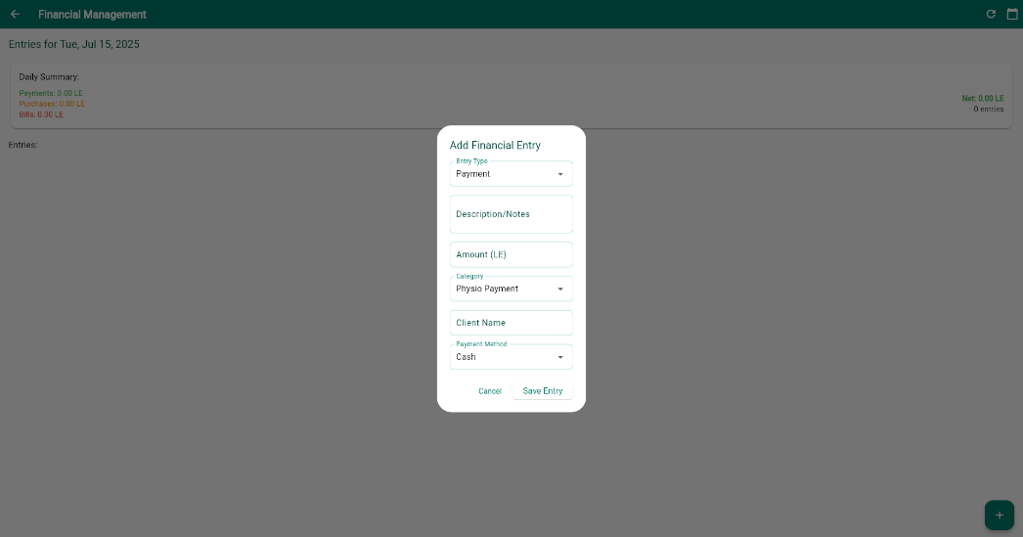
- Benefit: Provides real-time financial insights, simplifies accounting, and empowers informed business decisions.

6. Centralized Dashboard & Reporting:
- At-a-Glance Metrics: Instantly see key performance indicators like Today's Appointments, Cancelled Appointments, Total Patients, and Available Slots. (Refer to Screenshots 40, 51)

- Benefit: Keeps you informed about your clinic's performance, allowing for proactive management and growth strategies.

Flexible Pricing Plans to Fit Your Needs
Zyverse Clinic Management System offers flexible packages to suit clinics of all sizes, from initial setup to ongoing support.
  - One-Time Setup & Customization Packages:
Package | Price | Details
Starter | 3500 EGP | Ready-to-use system without customization
Professional | 7000 EGP | Full customization – Reports – Clinic name integration
Enterprise | 12,000 EGP | Logo, modifications, 6 months technical support, customized reports

  - Monthly Subscription Plans:
Package | Monthly Price | Benefits
Basic | 400 EGP | Single user access – Limited support
Pro | 700 EGP | Reports – WhatsApp integration – 2 users
Premium | 1000 EGP | Direct support – Custom reports – Multiple clients/branches

  - Ready to Transform Your Clinic?
Discover how Zyverse Clinic Management System can revolutionize your medical practice.
[Button: Request a Free Demo] See Zyverse Clinic Management System in action and explore its full potential for your clinic.
[Button: Contact Our Sales Team] Have questions? Our experts are ready to assist you.

  - Contact Us:
- Email: zyverse.dev@gmail.com
- Phone: 01024375442
- Website: Zyverse.com

